***Create step by step a simple maven project in Eclipse IDE.***

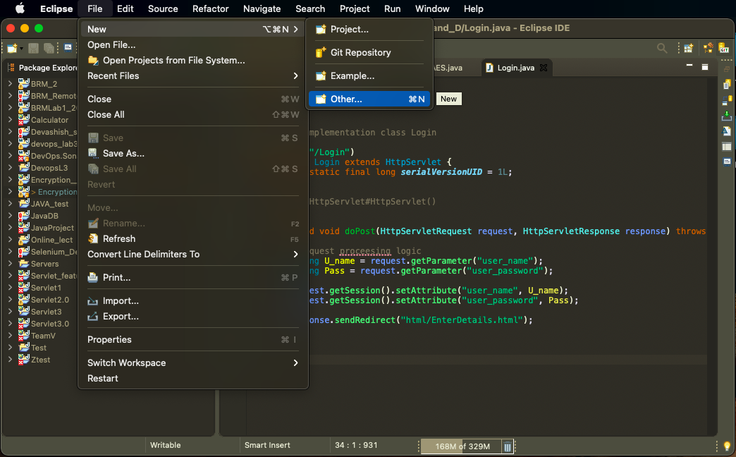

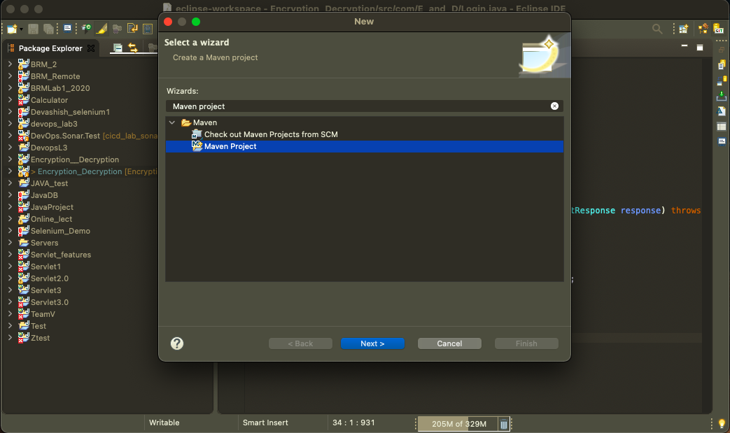

**Step-2**

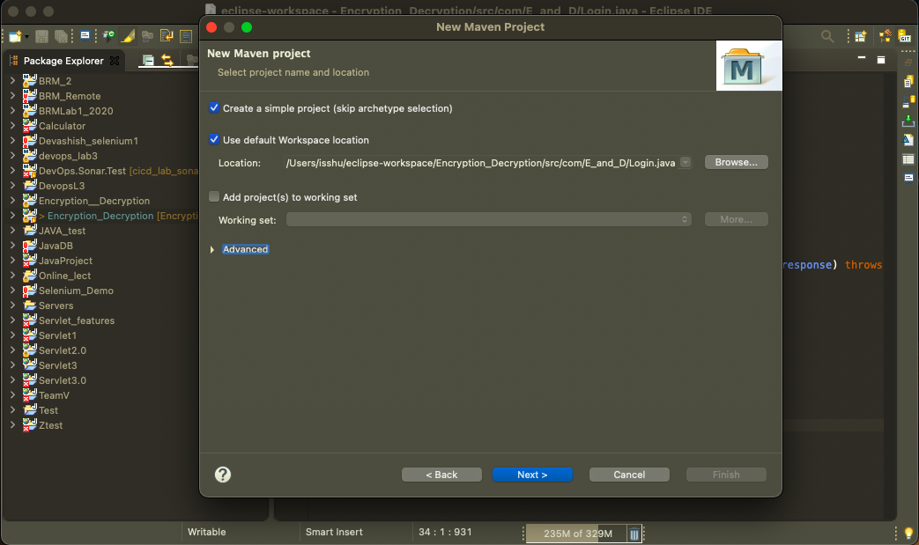

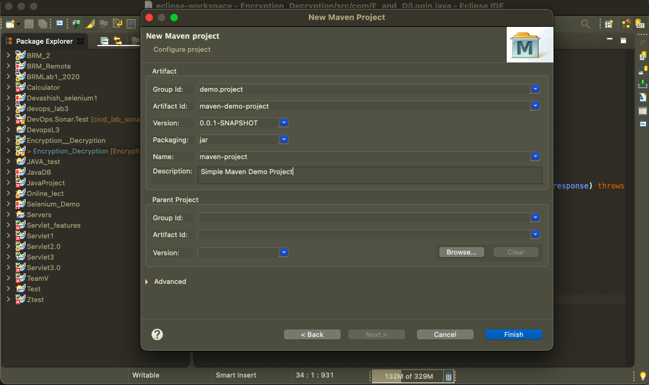

**Step-4**

And you are all set. You should see a new Project in Eclipse with below structure.

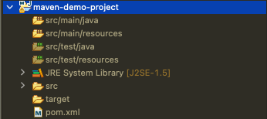

## Step-5

As you can see in the maven project structure, the default java compiler version ( i.e. source and target setting ) is 1.5. To change the default settings, add the following snippet to**pom.xml**.

<**build**>

<**plugins**>

<**plugin**>

<**groupId**>org.apache.maven.plugins</**groupId**>

<**artifactId**>maven-compiler-plugin</**artifactId**>

<**version**>3.6.0</**version**>

<**configuration**>

<**source**>1.8</**source**>

<**target**>1.8</**target**>

</**configuration**>

</**plugin**>

</**plugins**>

</**build**>

## Step-6

Add some dependencies to **pom.xml** file. Here we are adding *junit* dependency to **pom.xml.**

<**project** xmlns=*"http://maven.apache.org/POM/4.0.0"* xmlns:xsi=*"http://www.w3.org/2001/XMLSchema-instance"* xsi:schemaLocation=*"http://maven.apache.org/POM/4.0.0 https://maven.apache.org/xsd/maven-4.0.0.xsd"*>

<**modelVersion**>4.0.0</**modelVersion**>

<**groupId**>demo.project</**groupId**>

<**artifactId**>maven-demo-project</**artifactId**>

<**version**>0.0.1-SNAPSHOT</**version**>

<**name**>maven-project</**name**>

<**description**>Simple Maven Demo Project</**description**>

<**dependencies**>

<**dependency**>

<**groupId**>junit</**groupId**>

<**artifactId**>junit</**artifactId**>

<**version**>4.12</**version**>

</**dependency**>

</**dependencies**>

<**build**>

<**plugins**>

<**plugin**>

<**groupId**>org.apache.maven.plugins</**groupId**>

<**artifactId**>maven-compiler-plugin</**artifactId**>

<**version**>3.6.0</**version**>

<**configuration**>

<**source**>1.8</**source**>

<**target**>1.8</**target**>

</**configuration**>

</**plugin**>

</**plugins**>

</**build**>

</**project**>

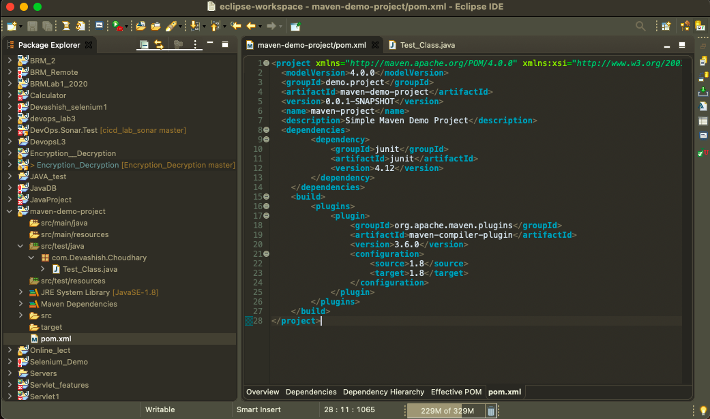

Let's test our created project by creating a simple JUnit test.

**Step-7**

package com.Bhavini.Mishra;

import org.junit.Assert;

import org.junit.Test;

public class Test_Class {

*@Test*

public void test() {

Assert.*assertEquals*("Hello Maven", new String("Hello Maven"));

}

}

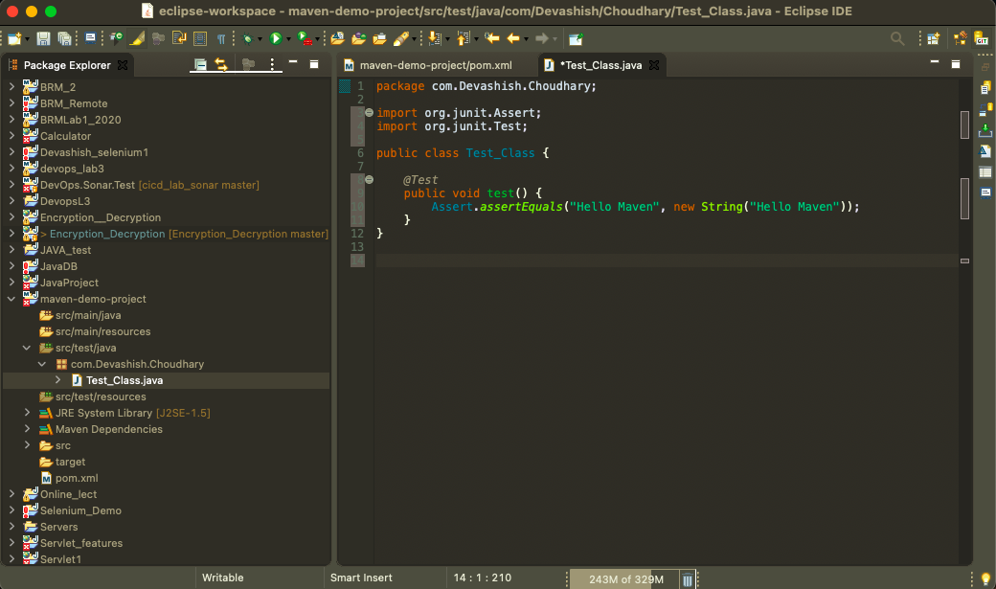

## Step-8

Run your first maven project. Right click on *AppTest.java* → Run as → JUnit Test.

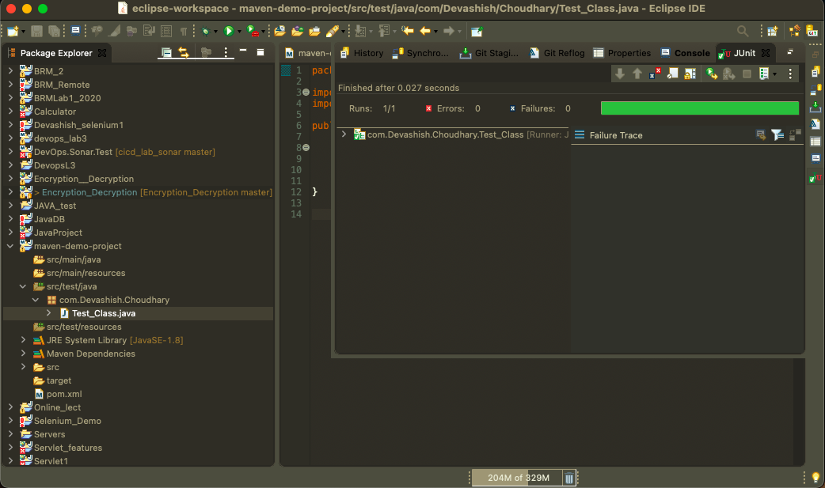

***Push the same running project on GitHub using Eclipse or IDE.***

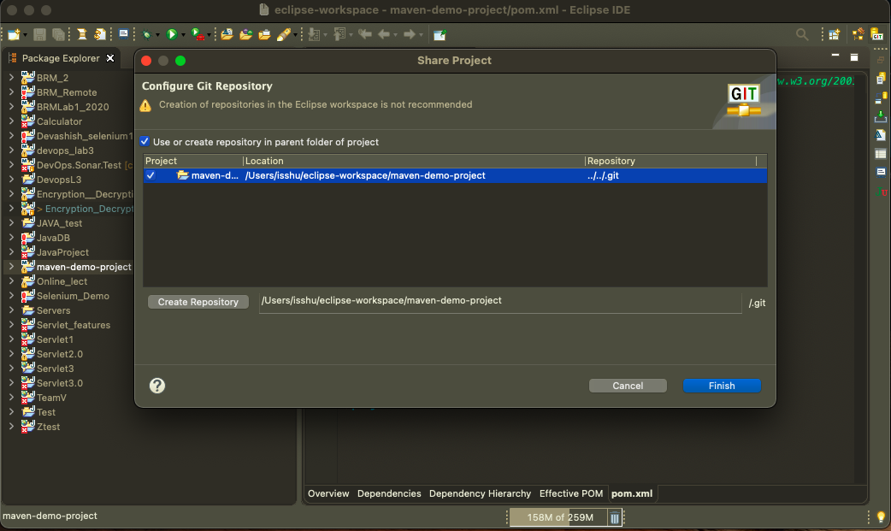

* **Create a new repository on your GitHub account with the same new of your project have.**

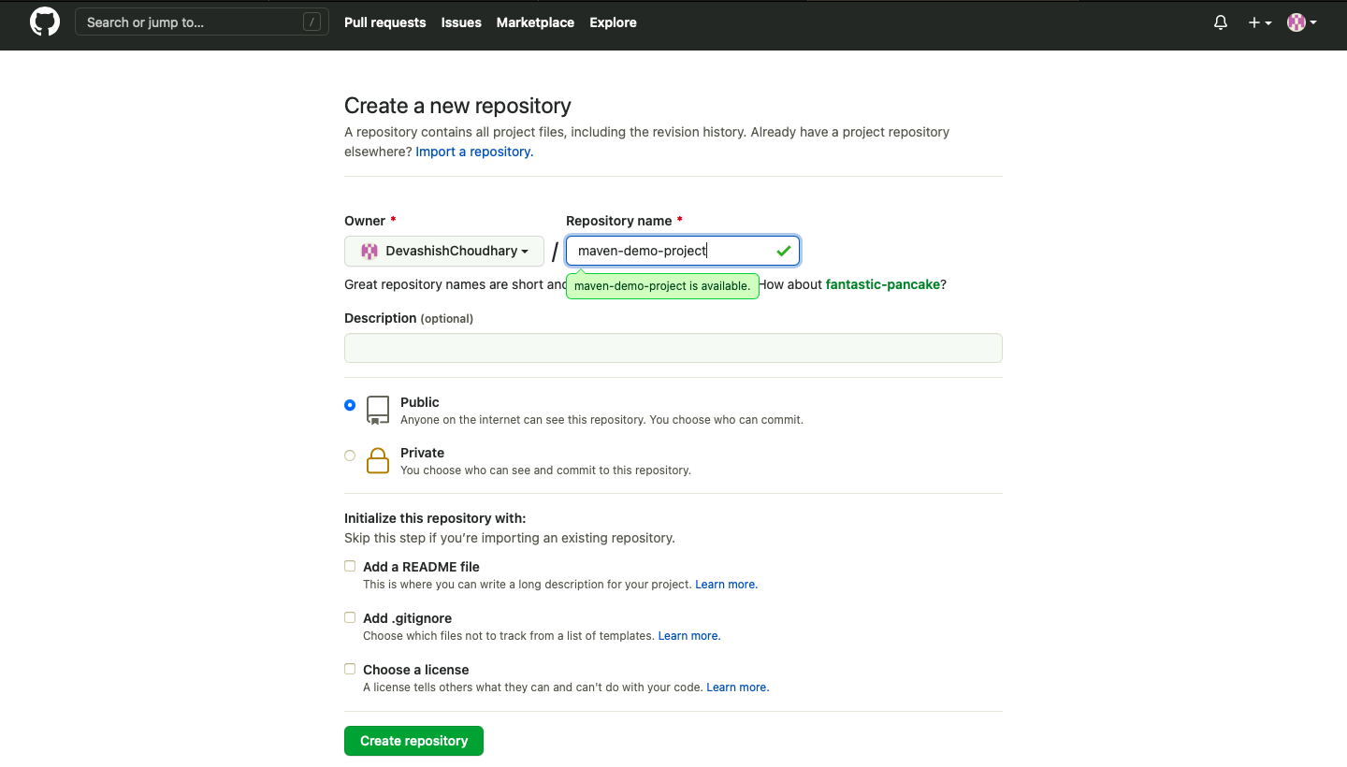

* Right click again to *Project* ->*Team* -> *commit* and move your project from **unstaged changes** to **staged changes** then **you are good to go for doing commit and push.**

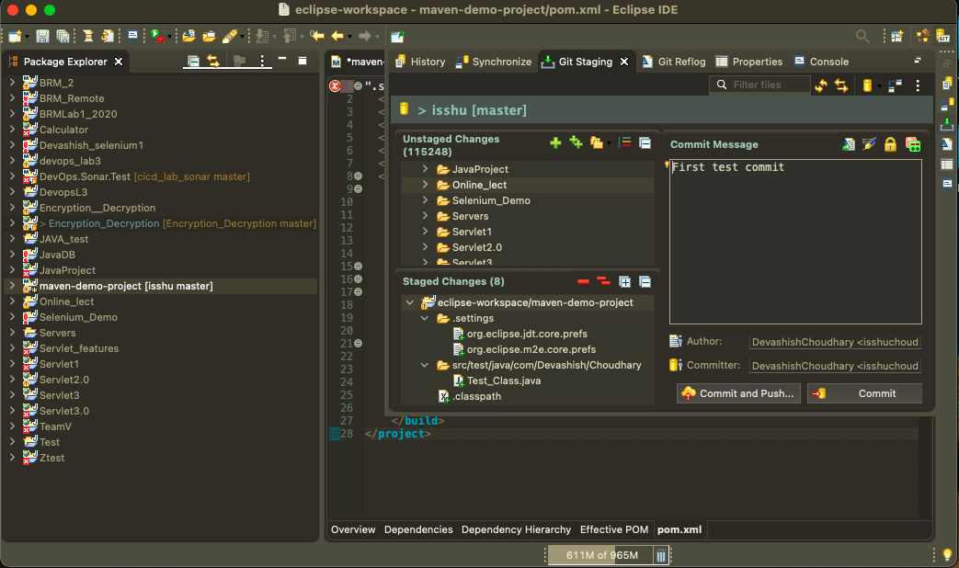

* Now you can see the project on your GitHub repository.

***Create a Jenkins Pipeline to generate build***

* Start the Jenkins service using the java -jar jenkins.war command in the command prompt and then go to the Jenkins dashboard at localhost:8080

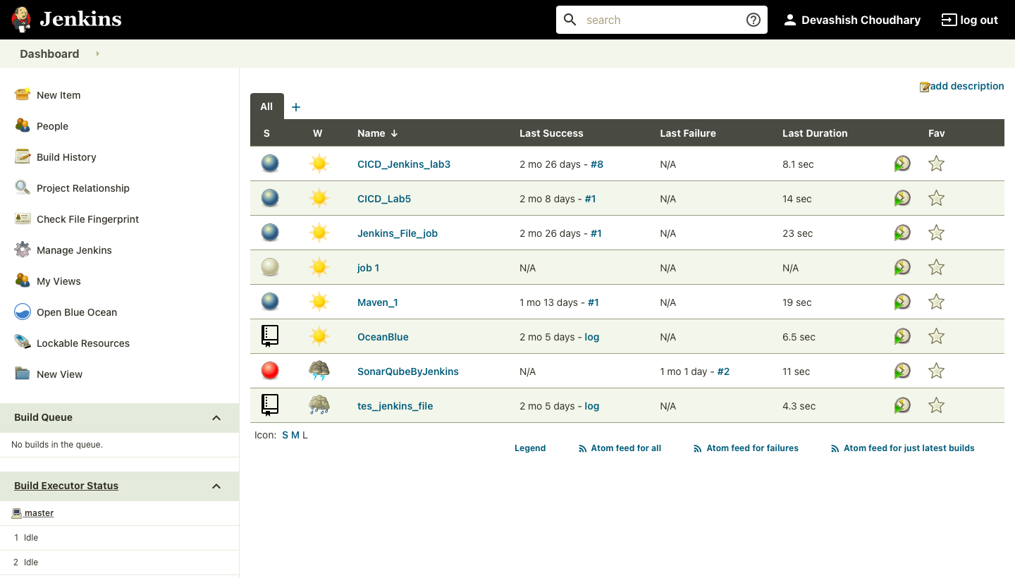

* Click on the new item option.

Select the pipeline option.

Give a name to the project (In my case the name is “Maven_Demo_Project”).

Click ok.

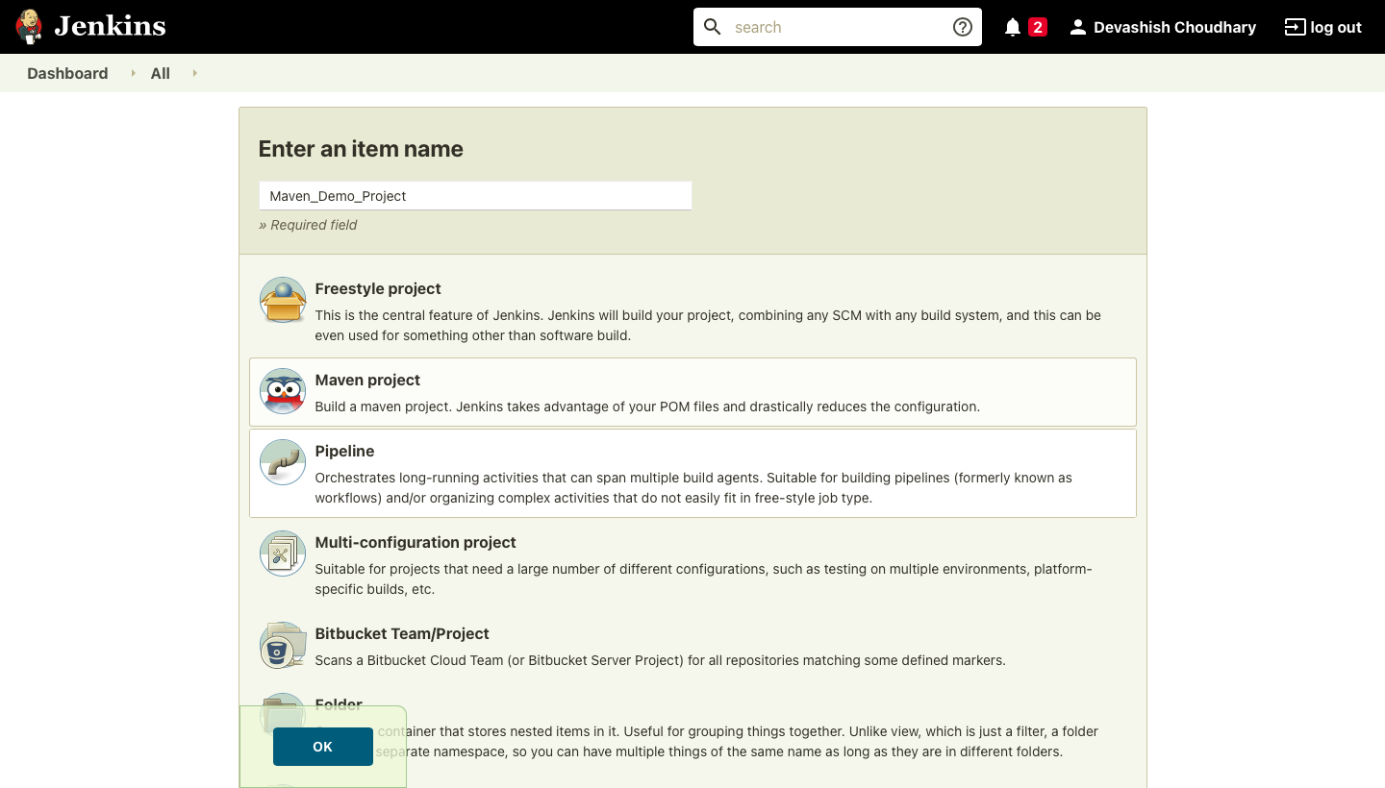

* You will be directed to a page similar shown below.

Click on the source code management tab to add the GitHub repository.

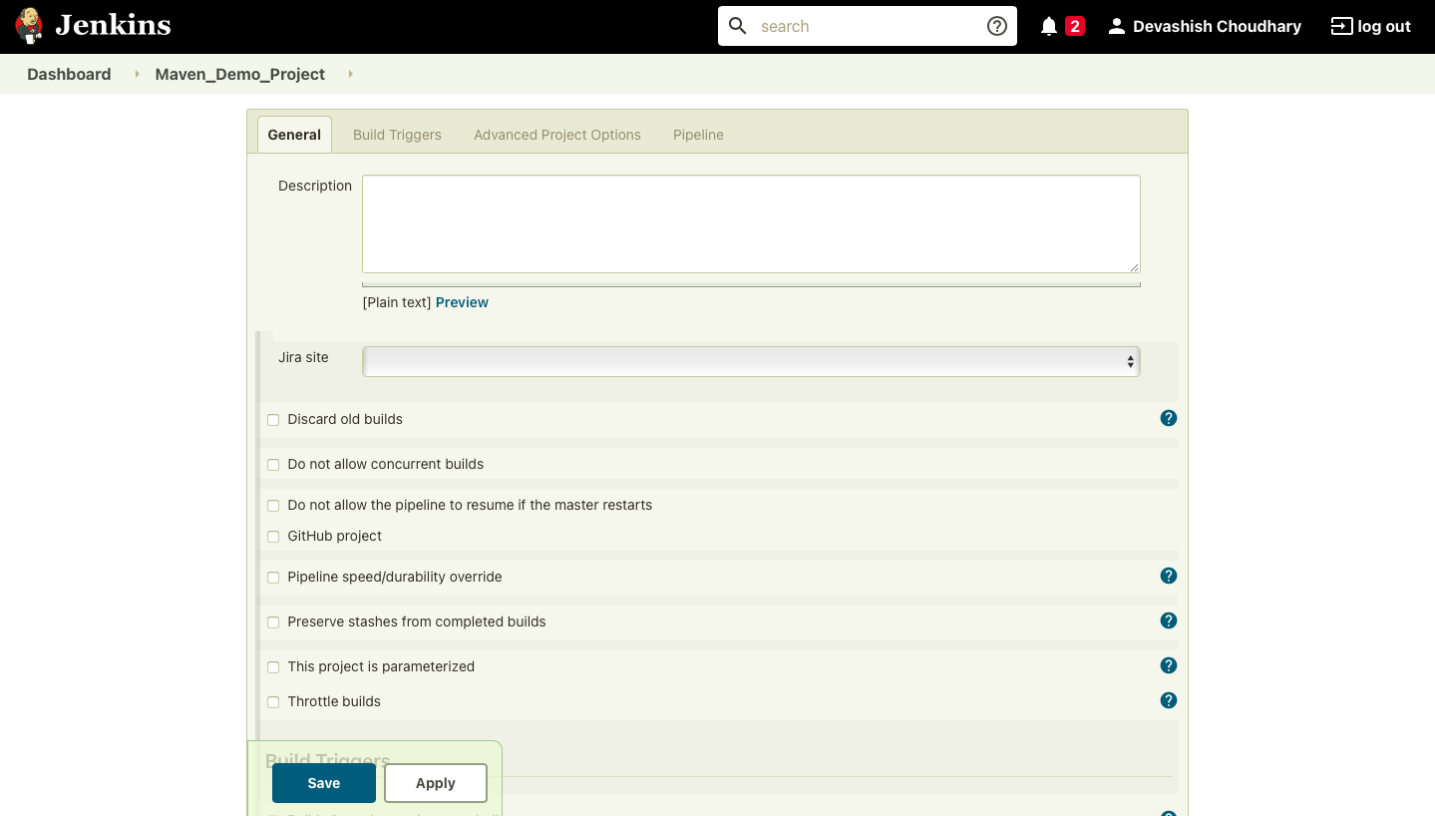

* Visit the repository where you saved your maven project

Copy the location of the GitHub repository

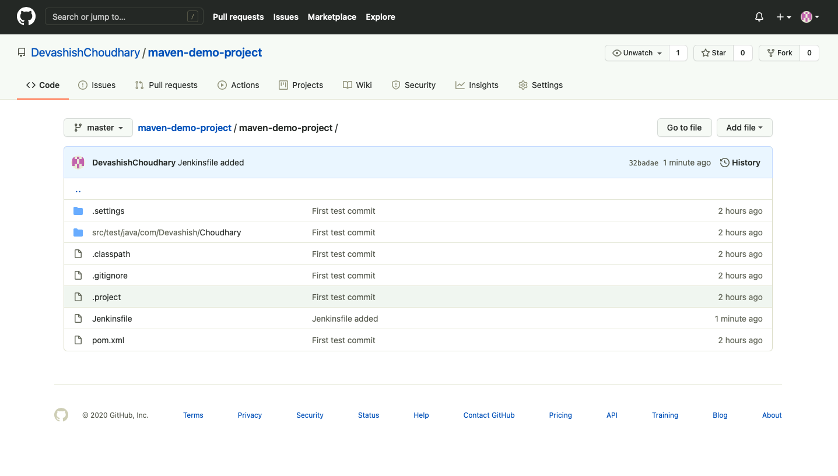

* The github repository has to contain a file named “Jenkinsfile” that tells the Jenkins server what tasks to do. In this example, it asks the Jenkins server to run 3 commands in 3 stages namely:
* echo “Build Stage”
* mvn clean
* echo “Clean Stage”

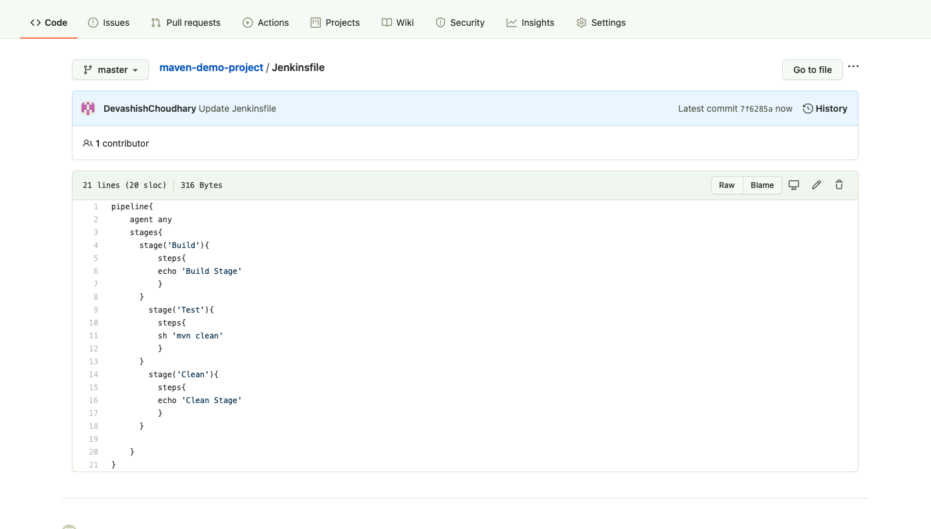

* In the Source Code Management Section select Git.

Give the repository location in the specified placeholder.

Click save and apply.

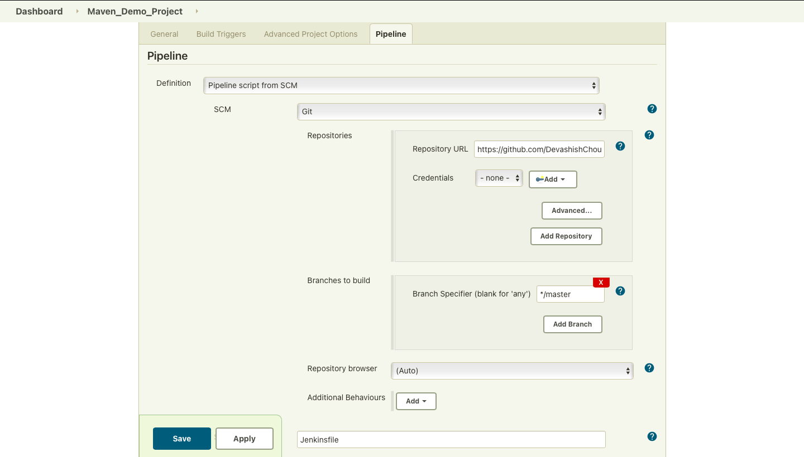

* You would be redirected to a dashboard like this after the build.

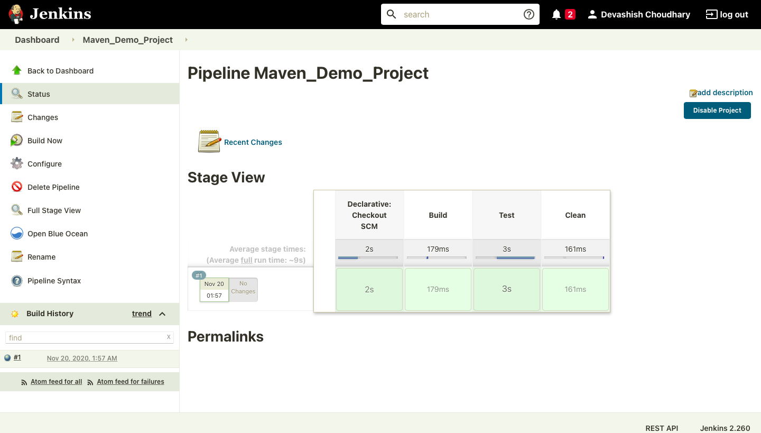

Console Output as shown below.

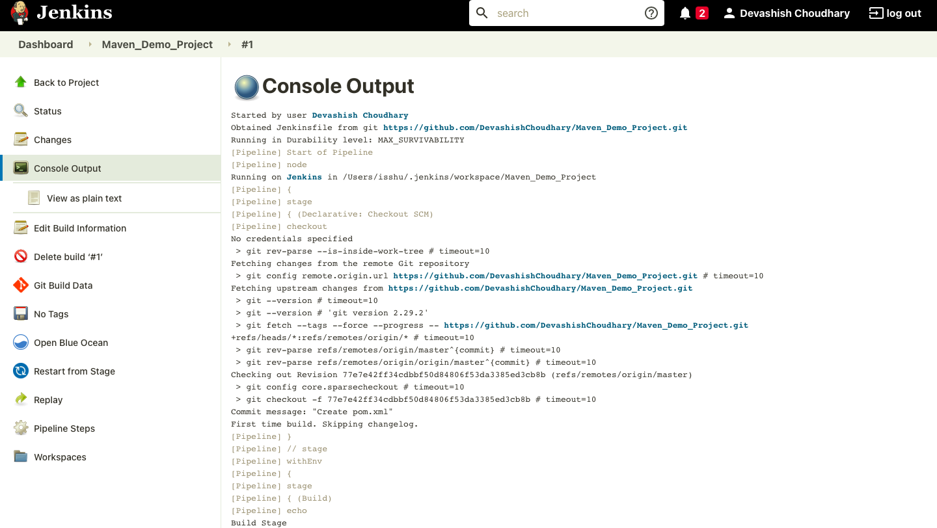

* If the build runs successfully it would return “BUILD SUCCESS”. It would return failure in case of any errors in the project.

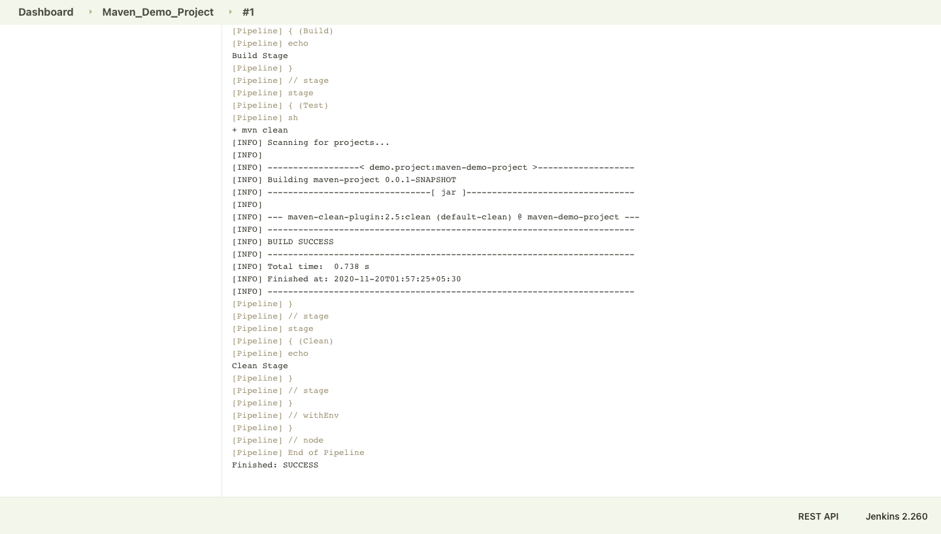

***Uploading Artifact on Nexus***

* Creating repository on Nexus as mention below:

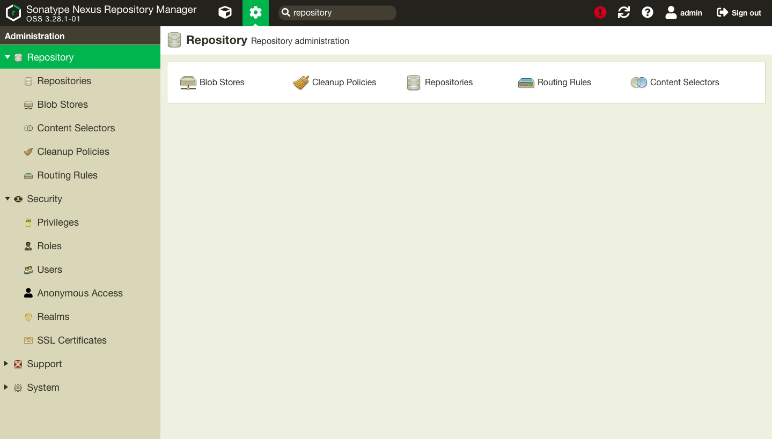

* Configure the new repository using “*maven2 (hosted)”*as shown below:

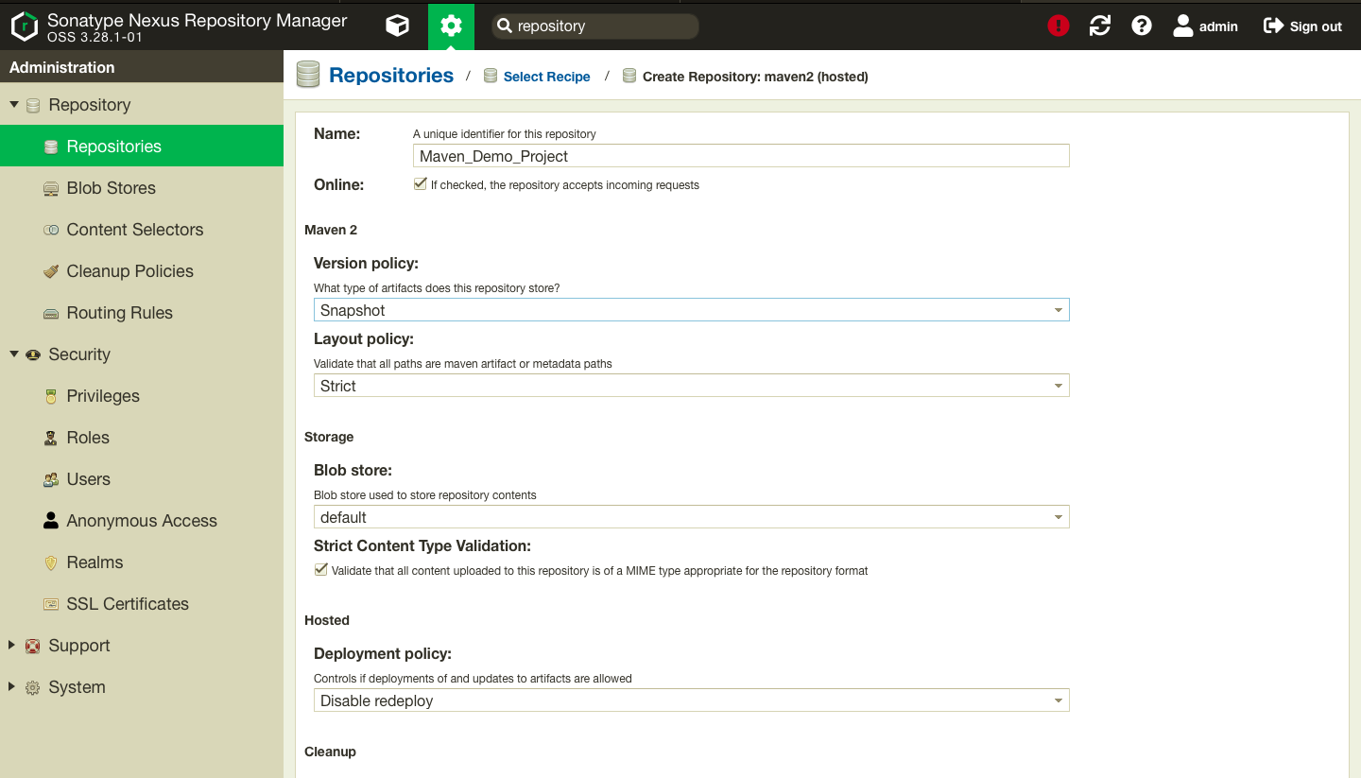

* Now you can see the created repository on your nexus Dashboard.

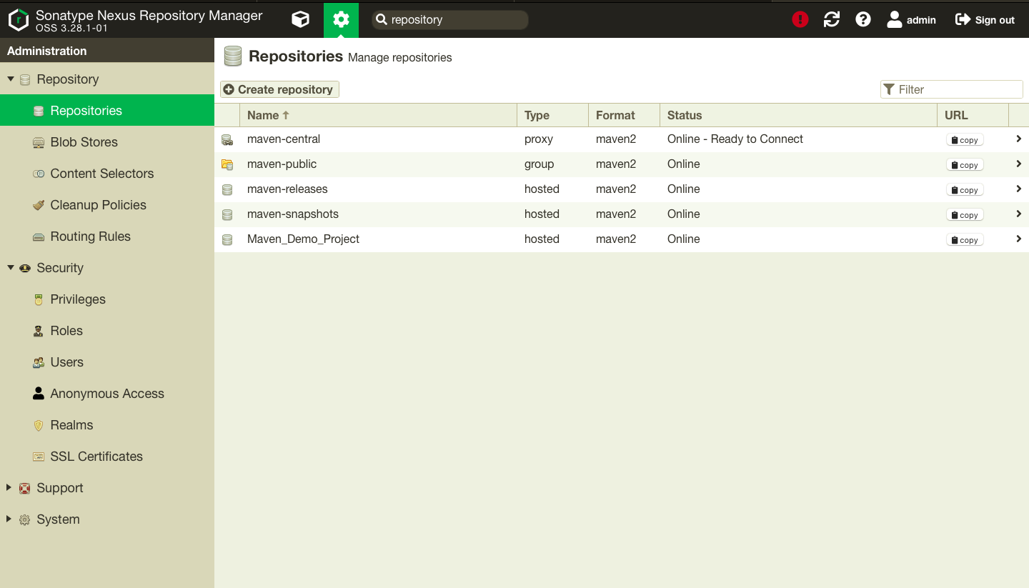

* Add the following code in the pom.xml file of your project accordingly to link the project with nexus.

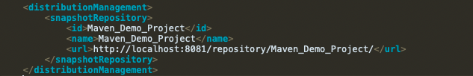

* Add the following server code in the *apache-maven-3.6.3/conf/setting.xml*

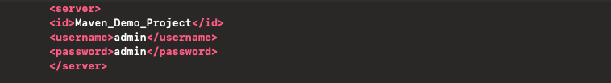

* See the following console output with different command:
* mvn clean

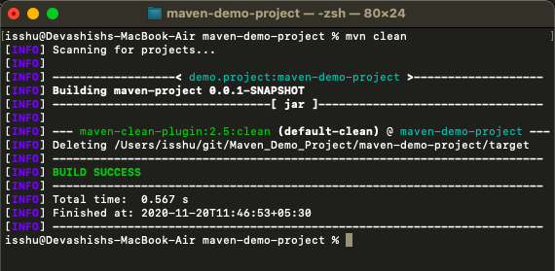

* mvn install

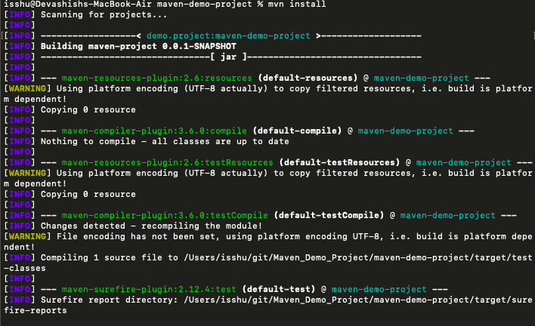

* mvn deploy

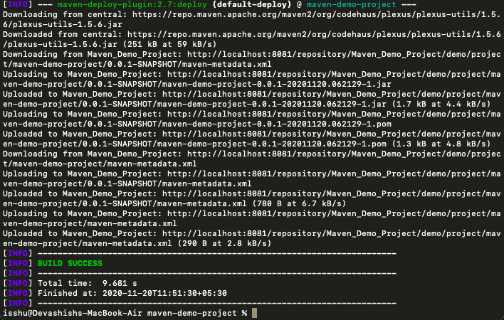

* Finally you have see all the report of your project on the dashboard of the nexus.

